Chapter 9, Problem 63.

For the circuit shown in Fig. 9.70, find the value of Z_{T}.

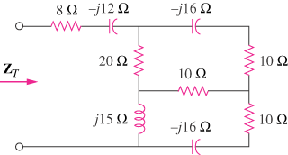

Figure 9.70
For Prob. 9.63.

